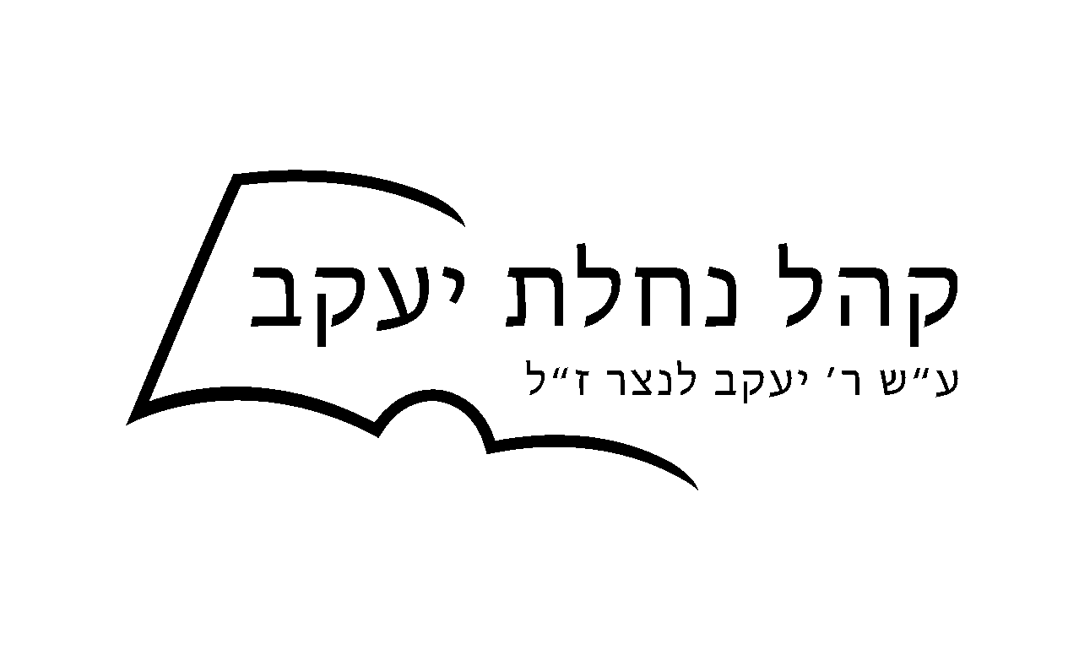

OFFICIAL TAX-DEDUCTIBLE DONATION RECEIPT
Please accept this email as an official receipt for your donation to Khal Nachlas Yakov
No goods or services were provided in return for the contribution.
Khal Nachlas Yakov is a tax-exempt charity under the IRS code section 501c3, Tax ID# 82-5289705

Contribution Information
Amount | $10 USD
Date | Dec / 21 / 2025
Billing Name
Yisroel Nusbaum

Payment information
Zelle | Transaction number: 27412770626

Please print this confirmation for your records.

Thank you for your donation

